DECORATOR AND GENERATOR

*Prepared By:*

*Nehal Patel*

*Prachi Patel*

*Pushti Patel*

**GENERATORS:**

Generators functions act just like regular functions with just one difference that they use the python **yield** keyword instead of **return.**

A generator function is a function that returns an iterator.

A generator expression is an expression that returns an iterator.

Generator objects are used either by calling the next method on the generator object or using the generator object in a “for in” loop.

**CODE:**

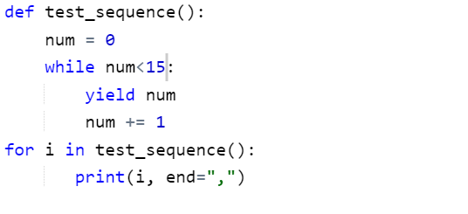

**Output:**

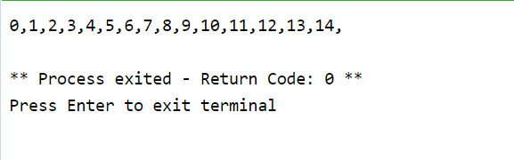

A **return** statement terminates a function entirely but a **yield** statement pauses the function saving all its states and later continues from there on successive calls.

**PYTHON GENERATORS WITH A LOOP:**

**CODE:**

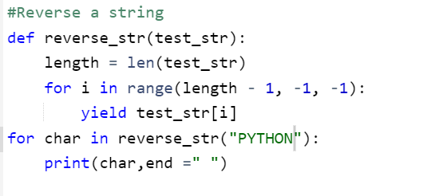

**OUTPUT:**

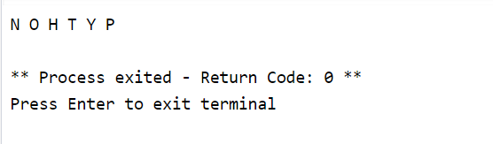

**GENERATOR EXPRESSION:**

Generator expressions can be used as the function arguments. Just like list comprehensions, generator expression allow you to quickly create a generator object within minutes with just a few lines of code.

**CODE:**

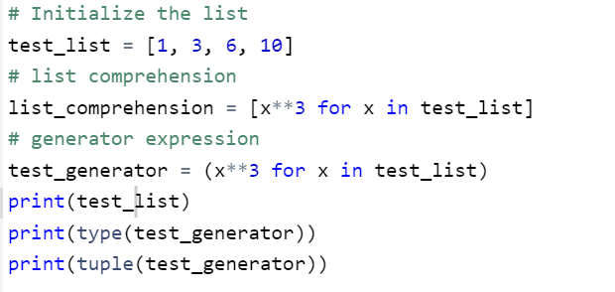

**OUTPUT:**

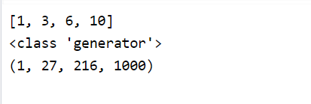

The major difference between a list comprehension and a generator expression is that a list comprehension produces the entire list while the generator expression produces one item at a time as lazy evaluation.

**DECORATOR:**

A decorator in python is any called python object that is used to modify a function or a class. It takes in a function, adds some functionality and returns it. Decorators are a very powerful and useful tools in python since it allows programmers to modify the behavior of function/class. Decorators are usually called before the definition of a function you want to decorate.

There are 2 different kind of decorators in python:

* Function decorators
* Class decorators

**CODE:**

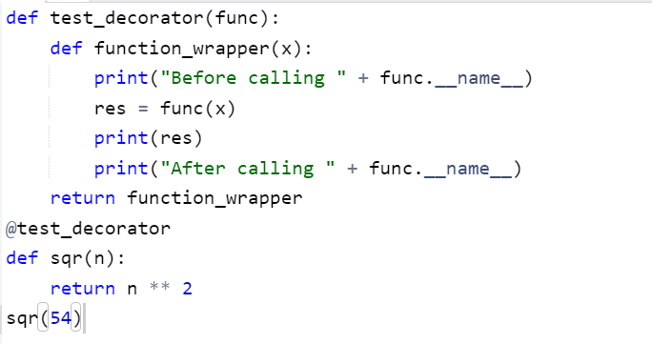

**OUTPUT:**

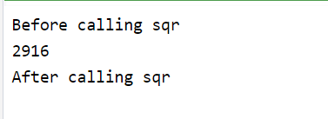

**MULTIPLE DECORATOR TO A SINGLE FUNCTION:**

When using Multiple decorators to a single function, the decorators will be applied in the order they called.

**CODE:**

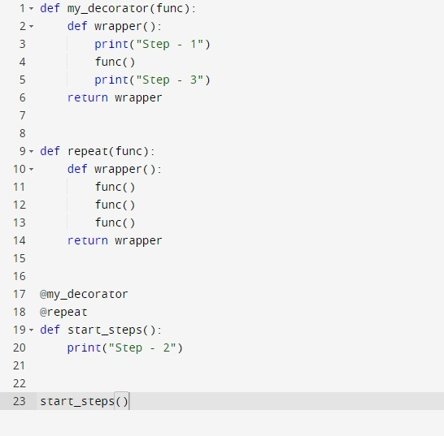

**OUTPUT:**

